**Practical No1: Caesar Cipher 29/08/22**

**Code:**

def encrypt_func(txt,s):

result=""

for i in range(len(txt)):

char=txt[i]

if(char.isupper()):

result+=chr((ord(char)+s-65)%26+65)

else:

result+=chr((ord(char)+s-97)%26+97)

return result

txt="PLAYSTATION"

s=4

print("Plain text is: "+txt)

print("Shift pattern: "+str(s))

print("Cipher text is: "+encrypt_func(txt,s))

**Output:**

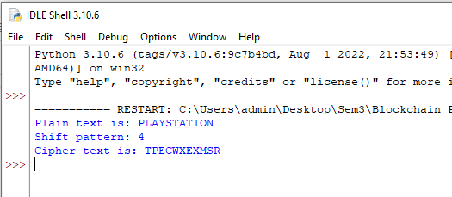

**Practical No2: RSA Encryption Algorithm 12/09/22**

**Code:**

try:

input=raw_input

except NameError:

pass

try:

chr=unichr

except NameError:

pass

p=int(input("Enter prime p: "))

q=int(input("Enter prime q: "))

print("Choose primes:\np="+str(p)+",q="+str(q)+"\n")

n=p*q

print("n=p*q= "+str(n)+"\n")

phi=(p-1)*(q-1)

print("Euler's function (totient) {phi(n)}:"+str(phi)+"\n")

def gcd(a,b):

while b!=0:

c=a%b

a=b

b=c

return a

def modinv(a,m):

for x in range(1,m):

if(a*x)% m==1:

return x

return None

def coprimes(a):

y=[]

for x in range(2,a):

if gcd(a,x)==1 and modinv(x,phi)!=None:

y.append(x)

for x in y:

if x==modinv(x,phi):

y.remove(x)

return y

print("Choose an e from a below coprimes array:\n")

print(str(coprimes(phi))+"\n")

e=int(input())

d=modinv(e,phi)

print("\n Your public key is a pair of numbers(e="+str(e)+",n="+str(n)+").\n")

print("\n Your private key is a pair of numbers(d="+str(d)+",n="+str(n)+").\n")

def encrypt_block(m):

c=modinv(m**e,n)

if c == None:

print("No Modular Multiplicative inverse for block "+str(m)+".")

return c

def decrpyt_block(c):

m=modinv(c**d,n)

if m==None:

print("No Modular Multiplicative inverse for block "+str(c)+".")

return m

def encrypt_string(s):

return ''.join([chr(encrypt_block(ord(x))) for x in list(s)])

def decrypt_string(s):

return ''.join([chr(decrpyt_block(ord(x))) for x in list(s)])

s=input("Enter a message to encrypt: ")

print("\n Plain message: "+s+"\n")

enc=encrypt_string(s)

print("Encrypted message: "+enc+"\n")

dec=decrypt_string(enc)

print("Decrypted message: "+dec+"\n")

**Output:**

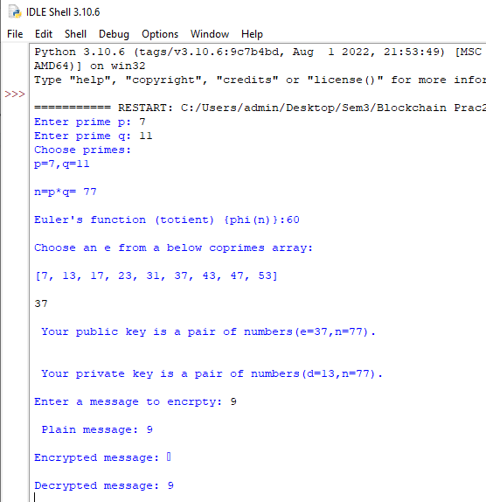

**Practical No3:SHA-256 19/09/22**

**Code:**

import hashlib

string="Playstation2020"

encoded=string.encode()

result=hashlib.sha256(encoded)

print("String :",end="")

print(string)

print("Hash Value: ",end="")

print(result)

print("Hexadecimal equivalent: ",result.hexdigest())

print("Digest Size :",end="")

print(result.digest_size)

print("Block Size :",end="")

print(result.block_size)

**Output:**

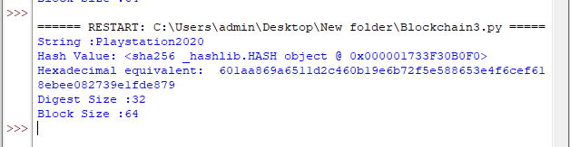

**Practical No4: Merkel Tree 19/09/22**

**Code:**

from hashlib import sha256

class MerkelNode:

"""Stores the hash and the parent."""

def __init__(self,hash):

self.hash=hash

self.parent=None

class MerkelTree:

"""Stores the leaves and root hash of the tree."""

def __init__(self,data_chunks):

leaves=[]

for chunk in data_chunks:

node=MerkelNode(self.compute_hash(chunk))

leaves.append(node)

self.root=self.build_merkel_tree(leaves)

def build_merkel_tree(self,leaves):

"""builds the Merkel tree from a list of leaves. In case of an odd number of leaves, the last leaf is duplicated."""

num_leaves=len(leaves)

if num_leaves == 1:

return leaves[0]

parents=[]

i=0

while i < num_leaves:

left_child=leaves[i]

right_child=leaves[i+1] if i+1 < num_leaves else left_child

parents.append(self.create_parent(left_child,right_child))

i+=2

return self.build_merkel_tree(parents)

def create_parent(self,left_child,right_child):

"""Creates the parent node from the children, and updates their parent field."""

parent=MerkelNode(self.compute_hash(left_child.hash+right_child.hash))

left_child.parent,right_child.parent=parent,parent

print("Left child: {}, Right child: {}, Parent: {}".format(left_child.hash,right_child.hash,parent.hash))

return parent

@staticmethod

def compute_hash(data):

data=data.encode('utf-8')

return sha256(data).hexdigest()

**Output:**

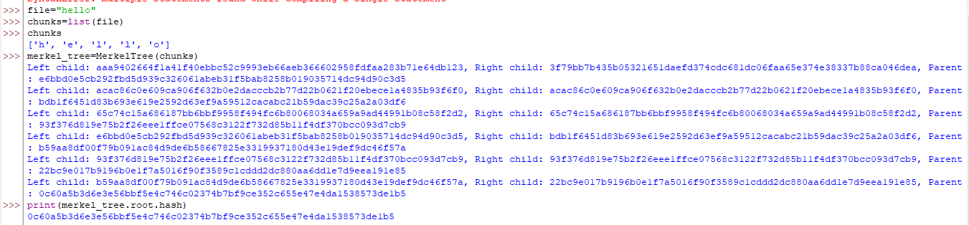

**Practical No 5: Implement the creation of Bitcoin Bloc/Blockchain(Genesis Block) 26/09/22**

**Code:**

blockchain=[]

def get_last_value():

return (blockchain[-1])

def add_value(sender,recipient,amount=1.0):

transaction={'sender':sender,'recipient':recipient,'amount':amount}

blockchain.append(transaction)

def get_transaction_value():

tx_sender=input('Enter the sender: ')

tx_recipient=input('Enter the recipient of the transaction: ')

tx_amount=float(input('Enter your transaction: '))

return tx_sender,tx_recipient,tx_amount

def print_block():

for block in blockchain:

print("Here is you block")

print(block)

again=True

while again==True:

tx=get_transaction_value()

s,r,a=tx

add_value(s,r,a)

print(blockchain)

more=input("add more block (Y/N)? ")

if more.lower()=='y':

again=True

else:

again=False

**Output:**

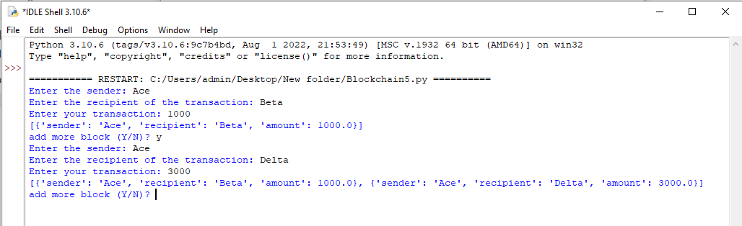

**Practical No 6: Implement the creation of a Blockchain(Adding the blocks to the chain and validating) 26/09/22**

**Code:**

#implent the creation of blockchain (Adding the blocks to the chain and validating)

import hashlib as hasher

import datetime as date

class Block:

def __init__(self, index, timestamp, data, previous_hash):

self.index = index

self.timestamp = timestamp

self.data = data

self.previous_hash = previous_hash

self.hash = self.hash_block()

def __repr__(self):

return "index %04d: \n Time %s, \n Data %s : \n Previous hash %s" % (self.index, str(self.timestamp), str(self.data), str(self.previous_hash))

def hash_block(self):

sha = hasher.sha256()

sha.update(repr(self).encode('ascii'))

return sha.hexdigest()

def create_genesis_block():

return Block(0, date.datetime.now(), "Genesis Block", "0")

blockchain = [create_genesis_block()]

previous_block = blockchain[0]

blockchain

def next_block(last_block):

this_index = last_block.index + 1

this_timestamp = date.datetime.now()

this_data = "Hey! I,m block " + str(this_index)

this_hash = last_block.hash

return Block(this_index, this_timestamp, this_data, this_hash)

num_of_block_to_add = 5

for i in range (0, num_of_block_to_add):

block_to_add = next_block(previous_block)

blockchain.append(block_to_add)

previous_block = block_to_add

print(repr(block_to_add))

print(" _ _ _ _ _ _ _ _ _ _ _ _ _ _ _ _ _")

def validate_blockchain(in_blockchain):

for current_position in range(1, len(in_blockchain)):

previous_position = current_position - 1

if in_blockchain [previous_position].hash_block() == in_blockchain[current_position].previous_hash:

print('Block %d is valid' % current_position)

else:

warn('Block %d is invalid! (%s)' % (current_position, repr(in_blockchain[current_position])))

break

validate_blockchain(blockchain)

**Output:**

